**Display**

Every HTML element has a default **display** value that dictates if it can share horizontal space with other elements. We can change this default **display** value to make each elements inline, block, or inline-block.

1. **Inline**

The default display for some elements, such as <em>, <strong>, and <a>, is called *inline*. Inline elements have a box that wraps tightly around their content, only taking up the amount of space necessary to display their content and not requiring a new line after each element.

The height and width of these elements cannot be specified in the CSS document.

The CSS display property provides the ability to make any element an inline element. This includes elements that are not inline by default such as paragraphs, divs, and headings.

display: inline;

1. **Block**

These elements fill the entire width of the page by default, but their width property can also be set. Unless otherwise specified, they are the height necessary to accommodate their content.

Elements that are block-level by default include all levels of heading elements (<h1> through <h6>), <p>, <div> and <footer>.

Similarly, we can make an element standing on its own line by changing the default display value.

1. **Inline-Block**

Inline-block elements can appear next to each other and we can specify their dimensions using the width and height properties (like images in Words).

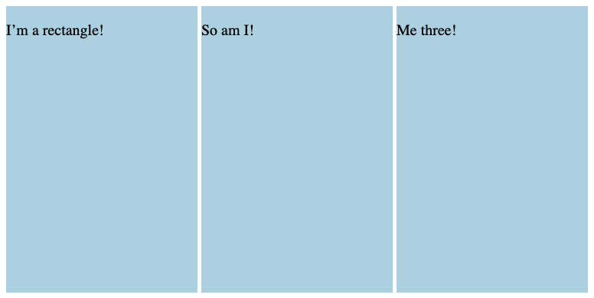<div class="rectangle">  
  <p>I’m a rectangle!</p>  
</div>  
<div class="rectangle">  
  <p>So am I!</p>  
</div>  
<div class="rectangle"> 🡪  
  <p>Me three!</p>  
</div>

.rectangle {  
  display: inline-block;  
  width: 200px;  
  height: 300px; (the inline-blocks will appear on the same line if there is  
} enough space from left to right)